## Kiwi Budget : A Database of New Zealand Economic Activities (1996 ~ 2022)

Authors : Ali, Jerry, Jeffrey

**Abstract**

This database contains information from various major social economical activities of New Zealand as well as its key monetary policy indicators. All data are time series based, they have been collected from websites like “interest.co.nz”, “interest.co.nz”, “interest.co.nz” and so on. The reuse potential includes finance department of New Zelanad companies for training machine learning algorithms that does the forecasting as well as visulisation. This database is available through xxx??

**KeyWords :** Monetary policy, Economic activities,

**How to Cite** :

## Overview

Repository location

<https://kiwi-economy/1996-2022>

### Context

Monetary policy that are measures employed by governments to influence economic activity, specifically by manipulating the supplies of money and credit and by altering rates of interest. The usual goals of monetary policy are to maintain full employment, to achieve high rate of economic growth, and to stabilize prices and wages. High CPI trends in the recent years, however, caused New Zealand governments to adopt measures that either stimulate the growth of the economy or reduced inflation by restricting growth in the money supply.

New Zealand is a relatively small economic entity that is heavily rely on oversea transactions like Tourism coming into the country and export our diary products

To better understand how does New Zealand economy response to these changes in monteary policies,

The official cash rate (OCR) was introduced in New Zealand in March 1999. It is a conventional tool by international standards. Before we had the OCR, we used a variety of tools to control inflation, including influencing the supply of money and indicating desired monetary conditions to the financial markets.

The Consumer Price Index (CPI) is a critical indicator of pricing pressures in an economy and provides a gauge of inflation. Forex traders monitor the CPI, as it can lead to changes in monetary policy by the central bank that will either strengthen or weaken the currency against rivals in the markets.

## Methods

### Step2

### 1: Sourcing, Tidying and Enhancing New Zealand Economy Dataset

### A: What data sources you used :

We have scraped data source such as 1) Historical CPI data, 2) Historical New Zealand Exchange Rate data, 3) Historical New Zealand Cargo Freight Transportation data, 4) Historical New Zealand Air Freight Data, 5) Historical New Zealand Tourism Count

1.What data model is in our minds for which we collected our datasets?

We intended to create a relational database that store both the New Zealand monetary policy data as well as NZ’s economical activities data.

2. Who is or can use our data model?

The intended users of our data sources are Like Air New Zealand CEO, KiwiRail CFO, Tourism New Zealand CFO and Reserve Bank policy maker, Ministers etc, who will be interested in finding how do our economical policy impact New Zealand main economy.

### B : Why you choose those data sources

New Zealand is a relatively small economical entity that is heavily relying on overseas business. Facing an increasing turbulent international political and economical environment (Russia and Ukraine war, Trade war between China and U.S. and covid-19 Pandemic), in order to maintain our prosperity, in depth analysis on how does New Zealand vital economical policy impact on our main economical activities are not only useful but also crucial for the success of these New Zealand companies. Expecially companies like Air NewZealand, Kiwi Rail and Tourism New Zealand.

### E : What techniques you did see

For data scraping, various techniques have been utilized for direct data file downing, web scraping,

CODE (Markdown ----)

### 2: Creating the Historical Monetary Policy & Economic Activities Dataset

### F : What you managed to achieve and what you failed to do

Our team decided to collect data that relates various social & economical activities in New Zealand; we will attempt to collect monetary policies data such as CPI, HPI, Exchange Rate as well as Inflation. Other economical activities data such as but not limited to “Transportation data”, “Ferry data”, “Tourism Satellite Account”.

The aforementioned data could come from different types of sources, we have observed data source type like “html”, “pdf”, “csv”, “excel file” and “Rest api”.

We plan to retrieve aforementioned data via these different sources first, then through the process of data wrangling to transform these data sources into relational database;

The final deliverable of our project should be a relationship database, that contains all aspects of New Zealand economic activities as well as government monetary policies. Such database can be utilized for further data mining analysis as well as data visualization tasks. We will plot a simple flow chart diagram to indicates the correlation between some of the chosen data, for example “Exchange Rate” VS. “Tourism Satellite Account”. It is anticipated that as exchange rate drops, New Zealand dollar becomes cheaper, we should be able to observe an increase of “Tourism account”.

The relationship key between these entities are timestamps (Year, Month, Quarter); Based on economical principles, as New Zealand Reserve Bank sets its interest rate up, business will have difficult of getting cheap loans for further development, it is anticipated that business development will be reduced, which leads to increase of unemployment. On the other hand, increase of Reserve Bank interest rate will attract oversea hot money for short term investment, therefore it is anticipated that exchange rate of New Zealand dollars VS. Other currency will go up. The high Reserve bank interest rate will lead to lower level of economic activities, hence in term of cargo freight statistics, general vehicle activities and tourism account, we are anticipating dropping in these activities. However, Reserve Bank raise interest rate usually to combat high inflation rate (CPI), therefore, we should be expecting dropping of the CPI.

When the economic activities are low and unemployment rate is high, the government is under pressure to unleash new monetary policies to stimulate economy. Hence government usually resolve to lower reserve bank interest rate. With high reserve bank interest rate, we should be able to observe weak New Zealand dollars VS over currency. Thus make export of our products cheaper, therefore attracts more oversea orders, subsequently we should be able to observe an increase of freight transportation activities, oversea passage flights. To stimulate general economic growth, government usually starts major infrastructural projects like major road works, etc. Hence it is also anticipated that general road construction activities are increasing.

The

## Database description



## Reuse potential

### The database can be potential reused for visulisations that can produce the inslights of the various kinds of ecnomic activities VS. Monetary policies indicators.

## Additoinal files

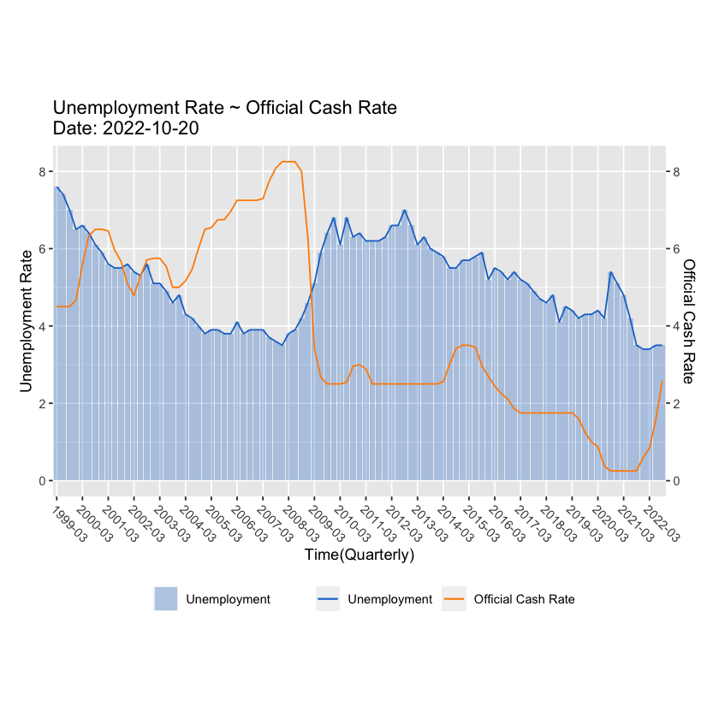

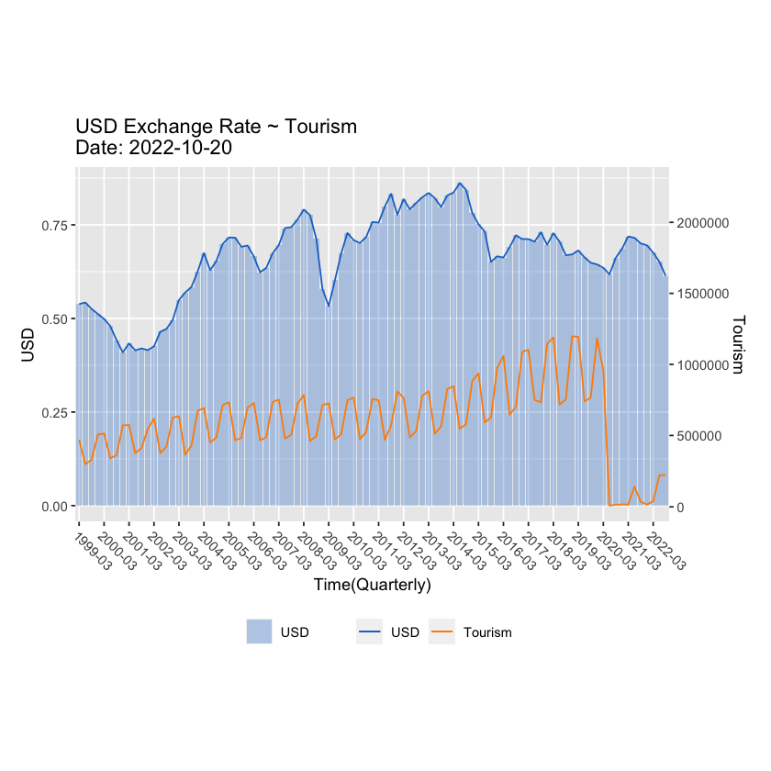

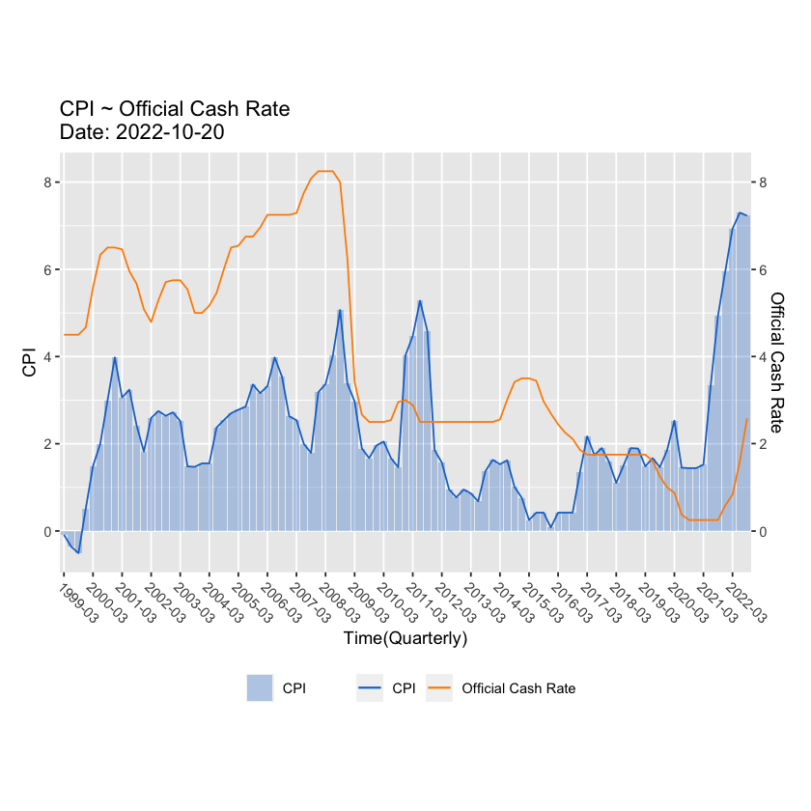

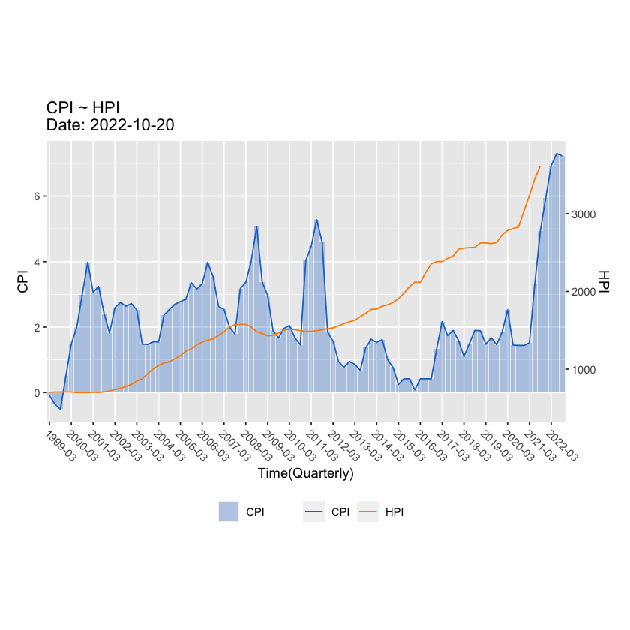

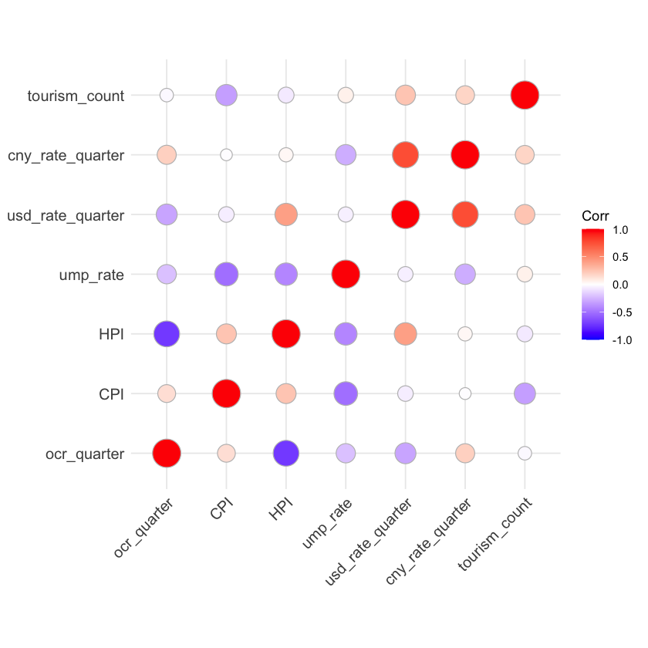

## Quality Control

(Data Wangling ---- Filtering …)

### D : What difficulties you have to overcome to wrangle the data sources into the target data model

We faced difficulties of finding keys between these entities, these historical data are not collected with the same frequencies. Some of them are collected on annual base, some of them are collected on monthly base and some of them are collected on quarterly basis. We need to wrangle these data to form unified keys for further construction of the relationship between these entities.

## Summary/Conclusion

## References (APA)

1. , <https://www.rbnz.govt.nz/monetary-policy/about-monetary-policy/the-official-cash-rate>